Introduction
“Discover Suriname” are words often used by tour operators and others in the travel business to request attention for Suriname, the smallest independent country in South America but with a Caribbean flavor instead of Latin American. Yes, Suriname is a country to discover, not only because it is not well known in the world, but more for what we have to offer the world: Cultural and religious diversity, pristine environments, including tropical rainforests and interesting estuarine areas both with a high biodiversity.
The country has a land area of 163,194 km² (appr. 63.000 mi²) and is situated on the northeast coast of South America, along the Atlantic Ocean, with Guyana bordering to the west, French Guyana to the east and Brazil to the south. Suriname, independent from the Netherland since 1975, is although small, still one of the least densely populated countries in the world, with 3.5 inhabitants per km². The country totals just 539,276 inhabitants (Census 2013).
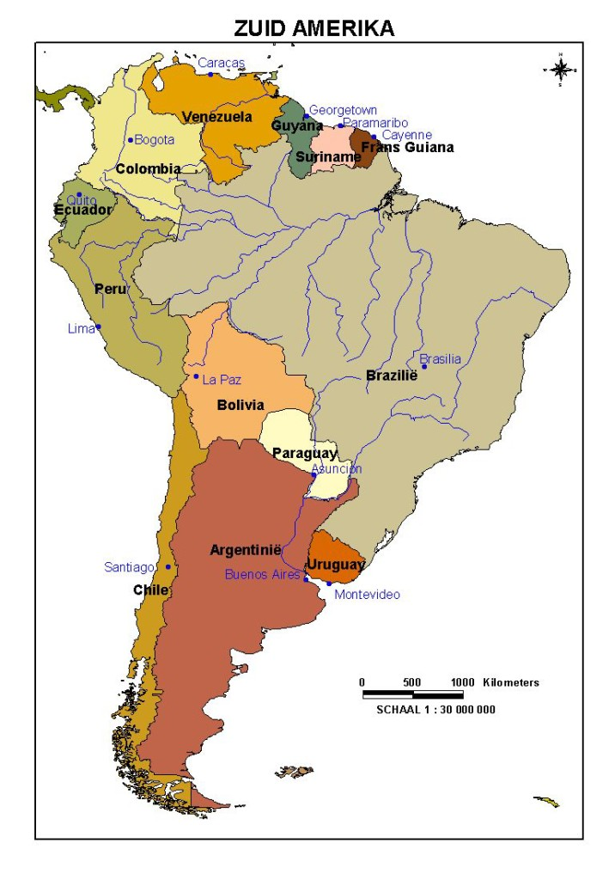

Population
The first stunning encounter with Suriname is the population. Creoles and Maroons of African descendants, Indians, Javanese and Chinese (descendants of colonial time immigrants) make up the majority of Suriname’s population. Indigenous people (native Amerindians) people of European descent; Lebanese and a blend of all the ethnic groups have formed Suriname into a country very diverse in ethnicity, culture and religion, with as many languages spoken as ethnic groups existing. Still tensions between the ethnic groups are absent resulting in a fairly harmonized society.
About 50% of the population lives in and around the capital of Paramaribo. This city is situated on the western bank of the mouth of the Suriname River, which divides the country almost equally into a western and an eastern part. Another 40% of the population lives in the coastal zone of the country, leaving 10% of the rest of the population, namely the Indigenous people and Maroons (together less than 5% of the population), to live in the large forested interior of the country. In the interior the Indigenous people and Maroons are living in tribes according to long existing traditions.

Architecture
Wandering through the centre of the capital of Paramaribo one will immediately notice the remarkable wooden buildings or the red brick buildings, referring to the Dutch architecture of colonial times. Religious buildings and houses of worship reflect the diversity in ethnicity and religious groups. Of special note are the Muslim mosque and the Jewish synagogue peacefully situated as brothers next to each other; the Roman Catholic Basilica, the Centrum Church of the Reformed Protestants and the Mamma Kerki (Grote Stad Kerk) of the Moravians.
The centre of the capital of Paramaribo is listed as a UNESCO World Heritage site, because of its architecture.

Nature
Suriname has a rich biodiversity mainly because of the low population density and the interesting landscape elements. The country is covered for more than 80% with pristine tropical rain forest. The coastal area of Suriname is characterized as an estuarine zone with vast areas of mudflats, mangrove vegetation and some sand beaches, which gain international importance because of the many waterfowl, including migratory shorebirds and egg-laying sea turtles on the sand beaches on the eastern shore of the country.
Suriname has always been prudent about nature conservation, and a substantial part of the country’s surface (about 13%) has a protection a status. The 1.6 million hectare Central Suriname Nature Reserve, in the center of the country is designated as a World Heritage site by UNESCO, and is one of the most pristine places on earth.

The Moravian Church in Suriname
In December this year the Moravian Church in Suriname, worldwide known as Evangelische Broeder Gemeente Suriname (EBGS) will commemorate 280 years of existence. The church has evolved from a Herrnhutter religious group working under the natives, the Maroons and slaves in the hinterland and on the plantations in the colonial times into an administrative independent Surinamese province with over 40,000 members spread over 14 regions, consisting of more than 60 congregations and outstations all over the country and in the District of CAS (Curaçao Aruba, and Saint Maarten, former islands of the Dutch Antilles). In French Guyana efforts to bring the gospel are made through the Mission Area.
Diaconal care is provided through the AMD (General Social Services), Huize Albertine (home for the elderly) and the Graaf von Zinzendorf Herberg. The latter operates low budget overnight facilities, but is primarily known for the care of people who are displaced because of e.g., domestic violence and the lost of their homes through e.g., fire.
The EBGS stood at the base of education, healthcare and entrepreneurship in Suriname.
Today the EBGS runs 74 primary schools (one in Curaçao) all over the country, including one school for mentally disabled children, nine secondary schools and, in cooperation with the Roman Catholic Church, one Teachers’ College. Children’s homes in the capital city and in the districts provide opportunities for children to visit school if there is none in their place of residence.
Theological education is provided by the Theological Seminary, which has a College for theological and pastoral education and is providing courses for lay-church-workers.
Moravian health care in Suriname dates from 1740 and focuses primarily on the inhabitants living in the remote areas of the interior. In 1999, forty-eight policlinics (incl. two field hospitals) and one hospital in Paramaribo were under the jurisdiction of the Medical Care Centre of the EBGS. In 2002 the Medical Care Centre of the EBGS merged with the Pater Albrinck Foundation of the Roman Catholics into the Foundation Primary Health Care Suriname. The hospital in Paramaribo is now under the jurisdiction of the EBGS, the Lutheran, and the Reformed Church.
We may say that industrial entrepreneurship started in Suriname with the entrepreneurial work of the Herrnhutters, resulting in the foundation of EBGS firm CKC (C. Kersten & Co.). Today the firm has been transformed into a holding company with a diversity of subsidiary companies, inclusive of the Hotel Krasnapolsky where the 4th Unity Women’s Consultation will take place.
All EBGS companies of Suriname, Curaçao and St. Maarten are part of the Moravian Church Foundation.
Submitted by:
Sr. Muriel Held, UWD Advisory Board Representative for the Caribbean

